Exp no:6 Determination and plotting of Capacitance of parallel plate capacitor in three different dielectric medium with specific area, dielectric thickness and various dielectric constant.
Aim:
To write program for capacitance of parallel plate capacitor in three different dielectric media using SCILAB.
Software required:
•SCILAB version 6.0.1
Theory:
Program:
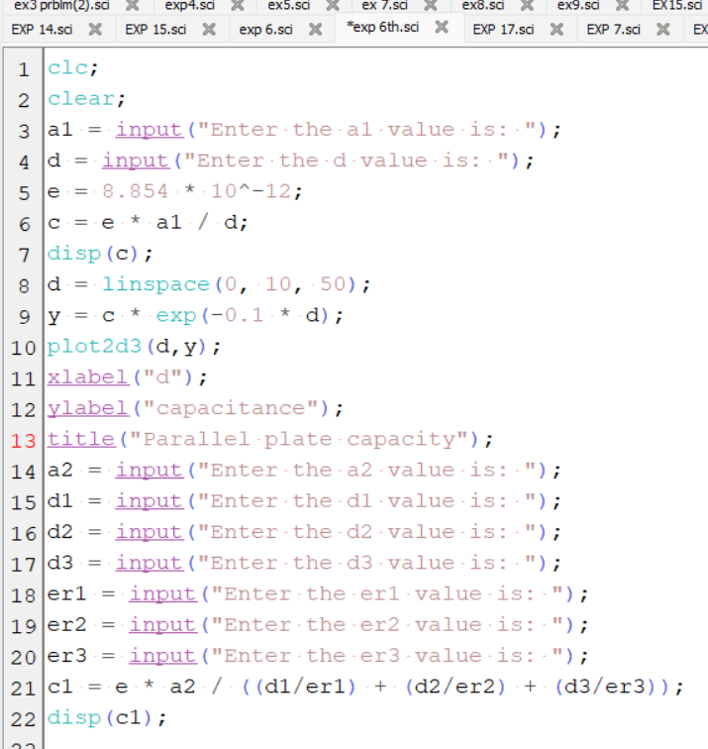

Output:
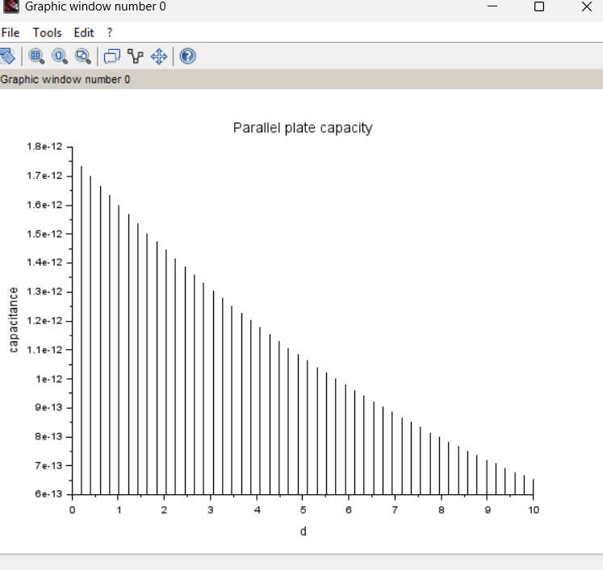
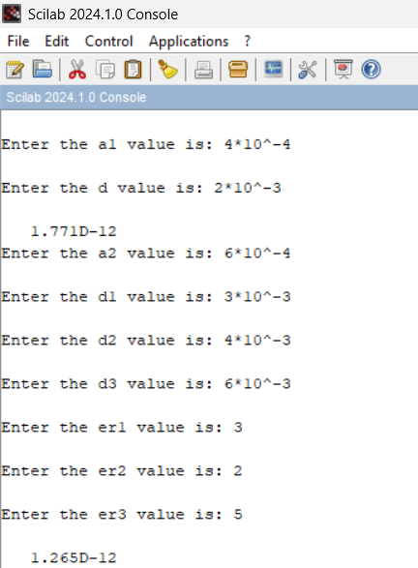

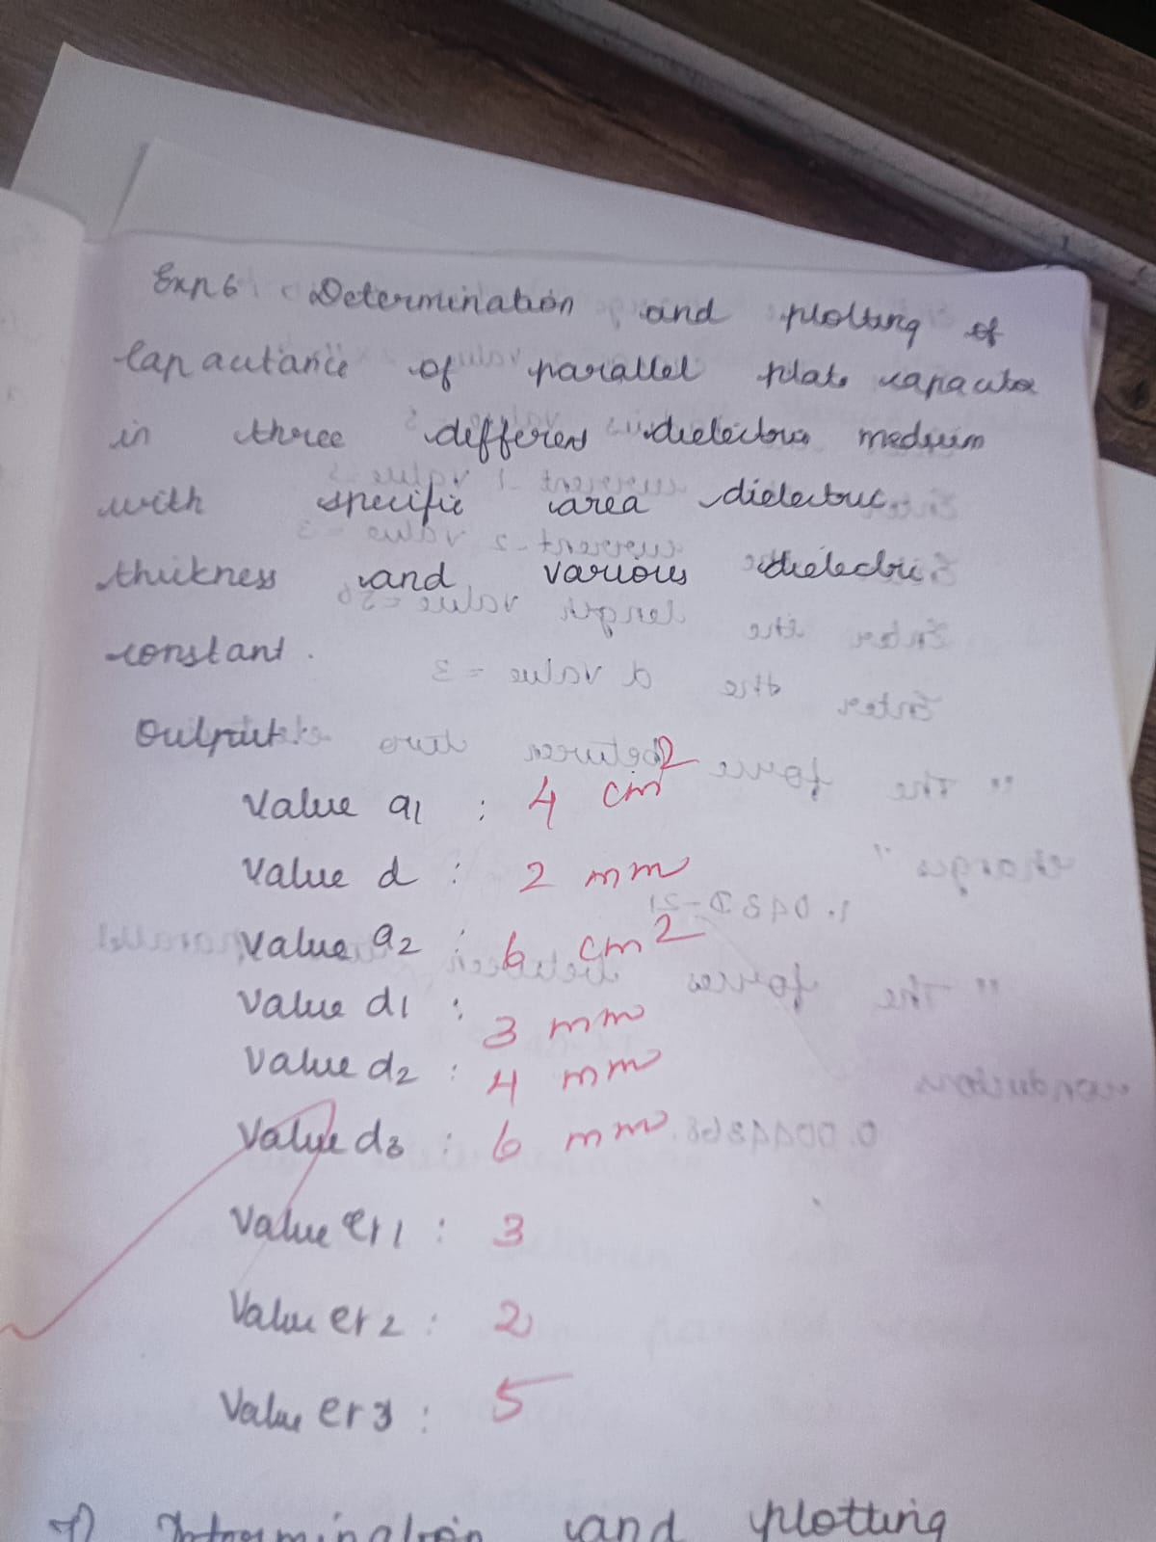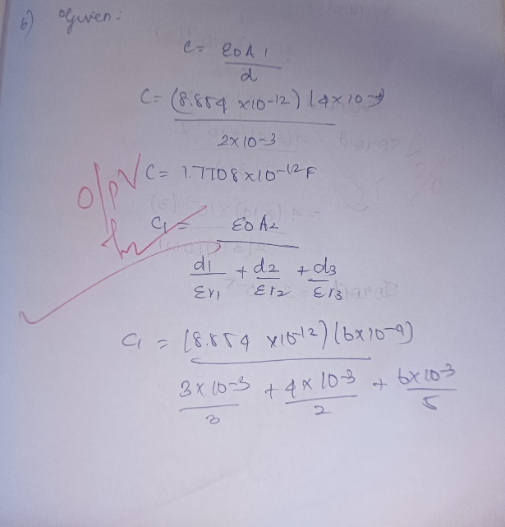

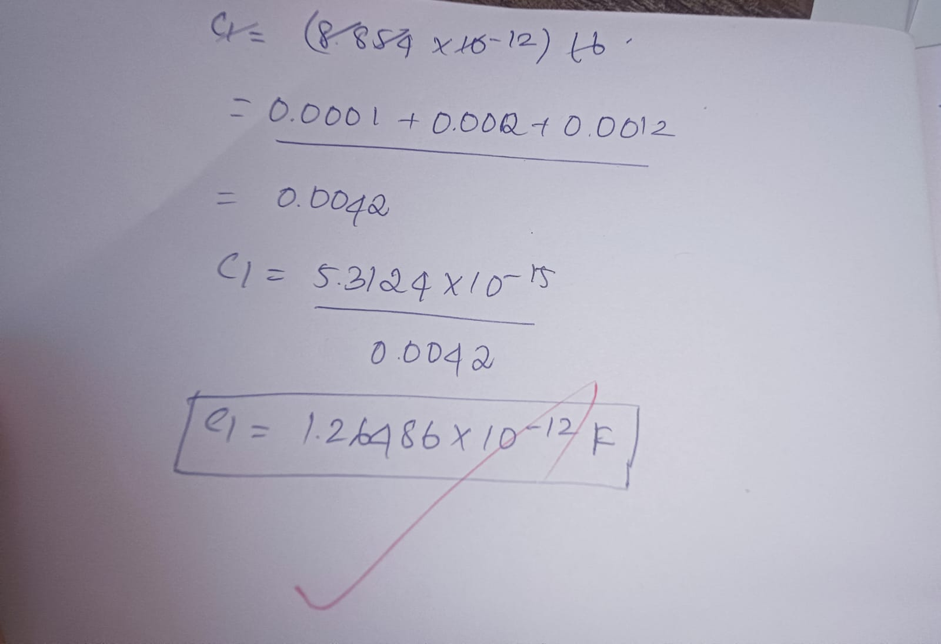

Case 1:
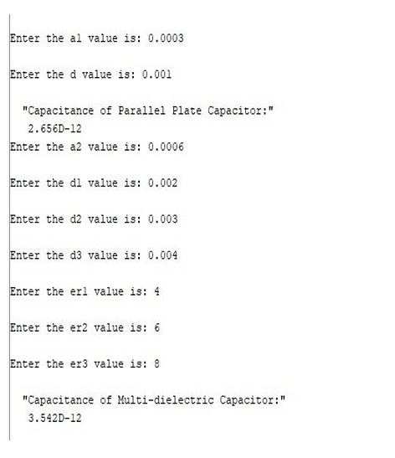
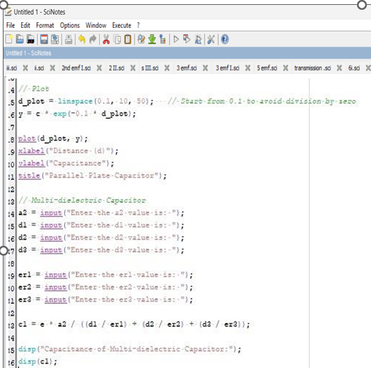
output:
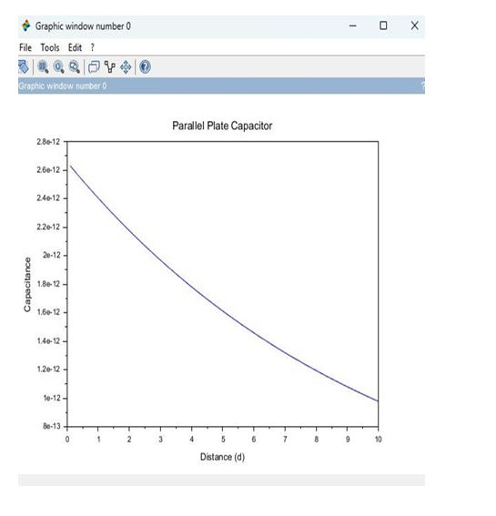
Case 2:

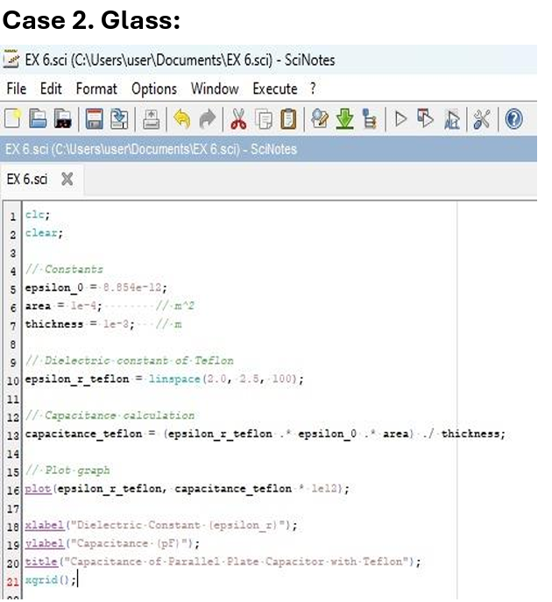
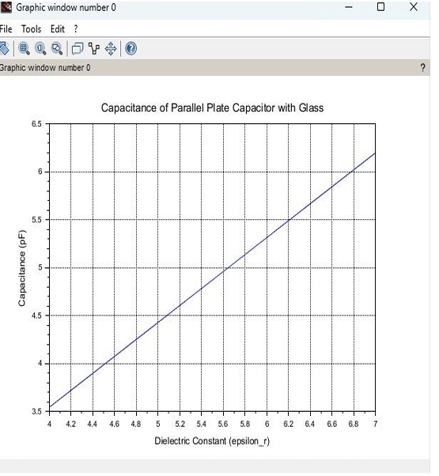
Output:
Case 3:
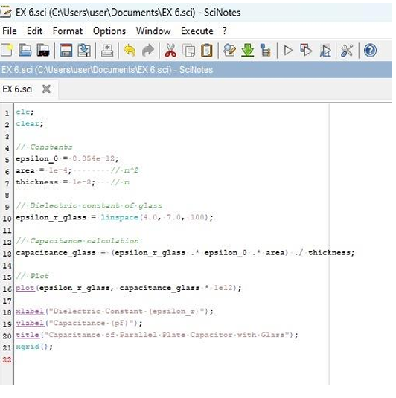
Output:
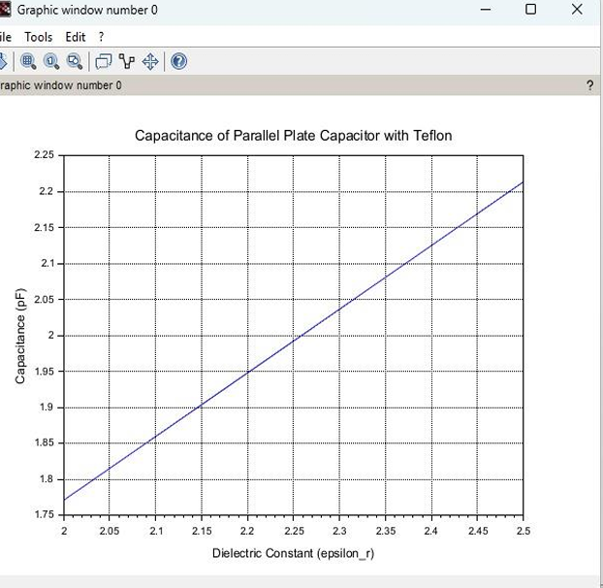
Result : Thus the program was verified for capacitance of parallel plate capacitor in three different dielectric media using SCILAB was successfully.

